Duo 2020 Key Facts
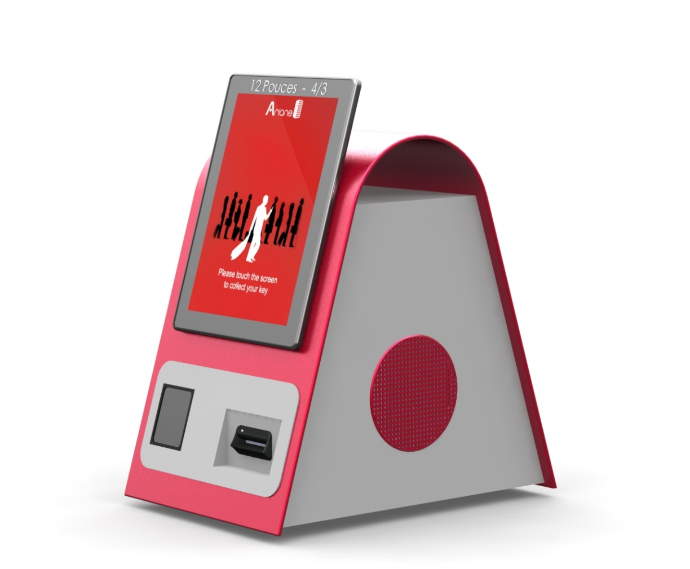
12” hi-res touch screen
QR Code Reader
150-200 key card stacker
Magnetic & RFID encoder

- Customizable GUI = approx. 5 day work
- Nb of possible encoded Keys by setup = 1 to 6
- Default or multi-language
- Single or reusable QR code
- Hardware options:
    - Ability to print a coupon and/or check-in receipt
    - ID verification before cutting a key

